**Jdev Installation Process**

Rename the files as below.

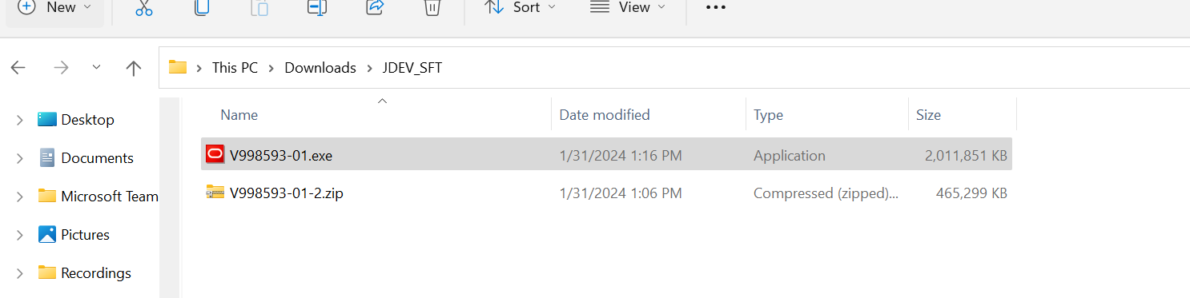

Open V998593-01.exe with admin role

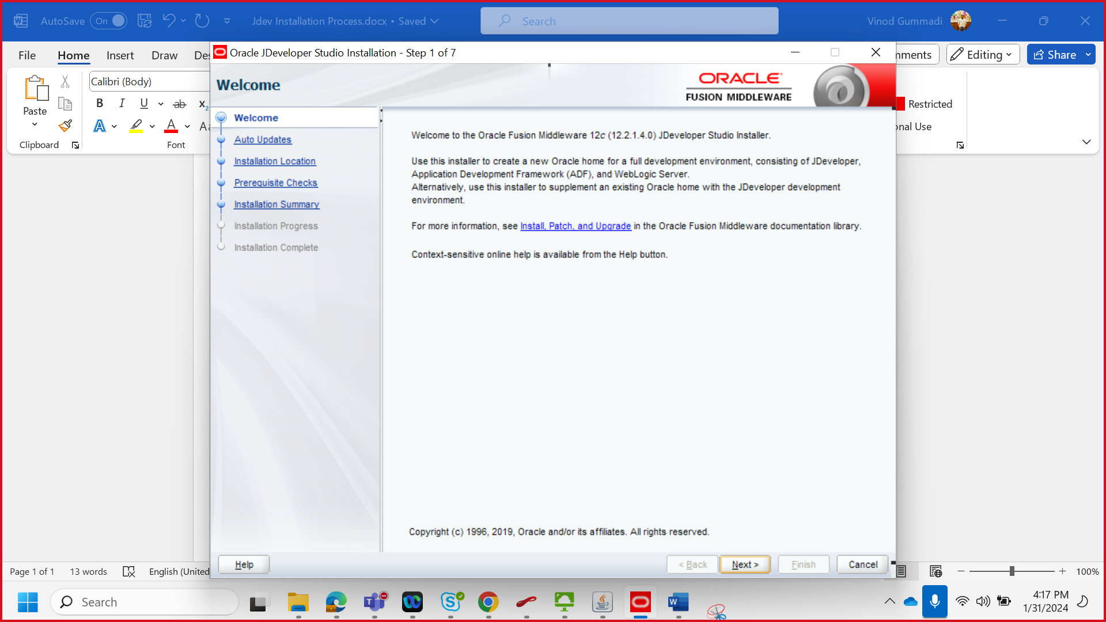

Create a folder in C drive (which drive u want to install) (if it’s not taking automatic)

Click install

